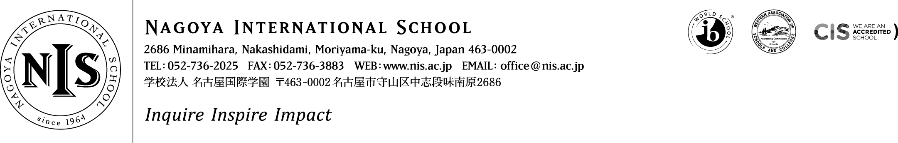

2021-2022 Positions Vacant

At NIS we are passionate about our mission – and we seek colleagues who share that passion. We want our students to puzzle, wonder and question the world around them, to choose to contribute to their communities and to articulate and follow their dreams. This is encapsulated in our school motto – Inquire, Inspire, Impact. It sounds ambitious, and it is - but we think it is important, and if you do too, we want to hear from you!

Early Childhood (Preschool) Teacher – Childcare Leave Cover
This is a short-term, non-renewable teacher position to cover the childcare leave of a teacher.

Dates of Contract
This position starts on October 11-15 (to be agreed) and terminates automatically on either June 18 or March 18. The end date for the contract will be determined by Jan 31, 2022. The successful candidate must be able to commit thru June 18 in any case.

Remuneration: Salary will be paid as per the appropriate NIS salary scale.

Applicants should consider applying based on the below requirements:
Essential:
- Full certification as a teacher of the lower elementary/early-childhood age-range
- A first degree in education or any other relevant field
- The ability to work as a collaborative member of a professional team of teachers within a PYP learning hub
Highly Desirable:
- Has completed PYP training and experience teaching in a PYP environment
- Experience with Reggio Emilia
- Is currently located in Japan

Applications should be made on the teaching application form available here

Thank you for your interest in NIS.

