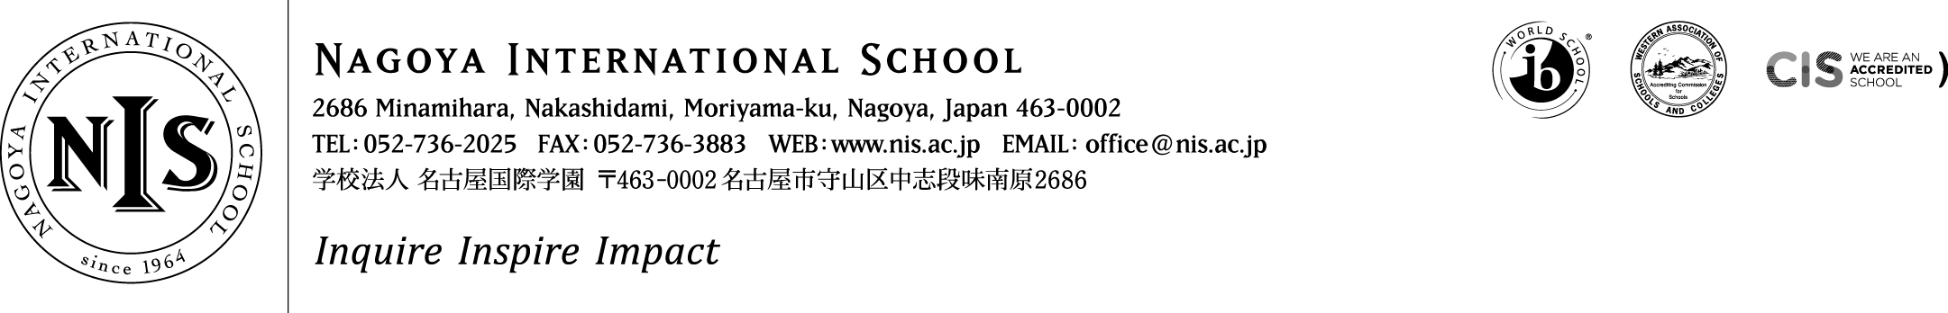
2022-2023 Positions Vacant

At NIS we are passionate about our mission – and we seek teachers and administrators who share that passion. We want our students to puzzle, wonder and question the world around them, to choose to contribute to their communities and to articulate and follow their dreams. This is encapsulated in our school motto – Inquire, Inspire, Impact. It sounds ambitious, and it is - but we think it is important, and if you do too, we want to hear from you!

Job Title: MYP/DP Chemistry/Science Teacher
NIS seeks a dynamic, enthusiastic and talented educator able to teach IBDP SL/HL Chemistry and MYP Science. The successful candidate will join the secondary school (Gr.6-12) Science department which includes a specialist in Biology, another in Physics, and two more staff who teach in both the Math and Science middle school MYP programme.
NIS seeks to cultivate classrooms in which there are more questions than answers and in which students and teachers work together with the shared goal of ever deeper learning. We seek a teacher who is able to help students not just master the details of the content, but also to understand the beauty of science as a means of connecting to our world.
NIS is an inclusive school serving a varied array of learners and the position will suit teachers who thrive in diverse classrooms and professional, collaborative cultures.

Applicants should consider applying based on the below requirements:
Essential:
- BA Degree in Chemistry (or closely related field) and a valid teaching certification
- At least five years’ experience as a full-time chemistry/science teacher in an international or national school offering programmes similar to NIS, at least two of which have included teaching chemistry at the IBDP level
- A commitment to collaborating with colleagues to make learning connected and meaningful
- A commitment to diversity, equity, inclusion, and justice in education and to serving a diverse array of learners
- A passion in holistic education and as much interest in being a teacher of students’ wellbeing (advisory/homeroom) as a teacher of concepts, skills and content
- The ability to provide/consent to clear police/background and medical checks

Highly Desirable:
- Experience of both the IBDP and MYP
- Experience as a workshop leader, examiner or similar in MYP science and/or DP chemistry
- Masters’ degree or higher in chemistry or in education

Please do not apply unless you meet the ‘essential’ requirements above and have read in full the details about living and working at NIS on the ‘working at NIS’ section of our website. The details of how to apply are also listed on the website here.
We hope to hear from you – and thank you for your interest in NIS.

